THIS IS A TEMPLATE/EXAMPLE VERSION
DON’T SEND THIS ONE IN – COPY YOUR ANSWERS INTO A BLANK FORM or delete the notes.
For BOSF members – we have used “friends of park” as an example – but just change for whatever your site/group name is.
ASSETS OF COMMUNITY VALUE (ACV1)
Nomination Form

Application reference number |  | Received date

Please complete the form legibly and return to the address below. Please mark as ‘Asset of Community Value Nomination Form, Confidential’ to:

ACV Nomination Application  Stirchley Baths Community Hub  2-4 Bournville Lane  Stirchley  B30 2JT | Tel: 0121 464 9072  Email: NDSU@birmingham.gov.uk

a) Applicant details – please provide the following details about your organisation
1) Who you are.

Full name of applicant organisation: …Friends of XXXXXX……..

Address: ..If you have an organisation address use that or whichever personal address you use for your group
……………………………………………………………………………………………
Postcode……… ……………………………

Website: if you have one……………………………
Details of person to contact about this application:
Name: …… ………………………………………………..

Position in organisation: ……eg are you the chair, secretary or a trustee?……………

Telephone number: …………………………

Mobile number…………………………………………....

E-mail address: …… ………………………

To assist with the initial processing of this application within Birmingham City Council please attach a copy of your organisation’s articles of association, memorandum, trust deed or constitution (as appropriate)

b) What kind of organisation are you? Please tick the appropriate box to indicate the kind of organisation you are to confirm your eligibility to make the nomination. Please note that the Council may request further information regarding your eligibility before accepting this nomination
i) Parish Councils. This may be for an asset in its own area, or in the neighbouring parish council. NB there is currently only one Parish Council in Birmingham, at Frankley.
ii) Neighbouring Parish Councils. If the parish council borders an un-parished area, then they may nominate an asset within the neighbouring district council or unitary council.
iii) Unincorporated groups. Nominations can be accepted from any unincorporated group with membership of at least 21 local people who appear on the electoral roll within the local authority, or a neighbouring local authority. This will for instance enable nomination by a local group formed to try to save an asset, but which has not yet reached the stage of acquiring a formal charitable or corporate structure
iv) Neighbourhood forums. There can only be one neighbourhood forum for an area and the way they are set up is clearly defined by the Council as a planning authority. The procedure for becoming a neighbourhood forum is set out in Section 61F of the Town and Country Planning Act 1990. NB in Birmingham most Neighbourhood Forums do not meet this definition and would fall into the category of being a community interest group.
v) Community interest groups with a local connection. These must have one or more of the following structures  a) A charity  b) A community interest company  c) A company limited by guarantee that is non profit distributing  d) An industrial and provident society that is non- profit distributing (these groups will be renamed as community benefit societies by the Co-operative and Community Benefit Societies and Credit Unions Act 2010 when it comes into force) e.g. co operative societies.  NB most organisations seeking to nominate an asset are likely to fall into this category. Non profit distributing means that any surplus of the organisation is not distributed to its members but is wholly or partly applied to Birmingham or a neighbouring authority. | Tick this box if you are a registered charity or charitable incorporated organisation (CIO) – include your charity number

c) Local Connection – please describe how your organisation has a local connection to Birmingham or a neighbouring authority. The Council may seek evidence to support your statement.

Friends of XXXX was set up in XXXX to protect and develop XXX Park as a resource for the whole community.

The park/open space/nature reserve/woodland etc was established in XX and has been in constant use as a public open space since then. There are no plans, that we are aware of, for it to be used in any other way in the future.
[it’s important that the site has been, is currently and will be in use by the community in the future]

Identify if there are any buildings on the site and how they are used by the community.

If the building has been used for residential purposes in the past eg Park Keeper’s house – this needs to be excluded from the application (when you draw your map make sure it is outside the line – see section 3 below

Identify if there are any other owners/leaseholders of the site and if they are supportive of the ACV

Since Friends of XXX Park was established, the group has worked to improve the space in a variety of ways:
- Improvements to the infrastructure – paths & benches, play equipment etc
- Horticultural management – including a programme of tree planting
- Running social activities to bring the community together
- Running activity sessions to improve the physical and mental wellbeing of the community
- Running the community building in the park
- Fundraising to enable these activities to happen
(add or take away from this list depending on what you do)

As a registered charity Of XXX Park has a board of volunteer trustees – xx people who live and work in the area.

Or – if you aren’t a registered charity

Friends of XXX Park has committee made up of XX volunteers – who (all) live or work in the area

There is a team of over XXX local volunteers who take on all the tasks:

- Gardening and conservation
- Repairs and maintenance
- Staffing the community building
- Organising and running social events and activity sessions
- Management of the charity/community group
(add or take away from this list depending on what you do)

We work in collaboration with a wide variety of other local organisations to help them make use of the park eg:
- Local schools:
- Uniformed youth groups – eg local scouts, cubs and beavers, sea cadets
- Non-uniformed youth groups – eg Youth Services
- Local faith groups
- Local sports and activity groups
(add or take away from this list depending on what you do)

Please confirm the following about your organisation and note that the Council carry out background checks into your organisation:

2) Details of your organisation’s governance structure

Neighbourhood Forum Registration NB remember that in Birmingham most Neighbourhood Forums do not meet this definition and would fall into the category of being a community interest group.
……………………………………………………………………

Company registration number: …………………………………………………………………….
CIC registration number: …………………………………………………………………….

Charity registration number: if you are a registered charity put your number here.

Friendly Society registration number: …………………………………………………………………….

Other: …or write constituted community group ………………………………….

Please note the details above may be shared with other parts of the Council, third sector organisations and other community partners for the purposes of processing your application.

3) Where is the land or building that you wish to see listed as an asset of community value?

This is to assist in the initial processing of your enquiry. Please attach a plan or map to this application – Google maps are useful for this purpose - showing the boundary of the asset to be listed indicating where possible if it has is more than one owner. This is to assist with identifying the asset to be considered for listing and the freehold or leasehold ownership(s) for each part of it.

Description of the land and its boundaries:

XXX Park is bounded by roads, the cross city railway line and the backs of houses on all sides. (do your own description – include EVERYTHING)
The roads around the park are: list them here
See screenshot from Google Maps below (get in touch with BOSF if you need help getting a screenshot from Google Maps)
Show where the entry points are – whether there are gates or not
If some of the space is owned/leased by other organisations show those areas
Identify if there are any buildings on the site and how they are used by the community.

If the building has been used for residential purposes in the past eg Park Keeper’s house – this needs to be excluded from the application (when you draw your map make sure it is outside the line – see section 3 below

Address………………………….,
Postcode…(pick the postcode for the main entrance) ……………
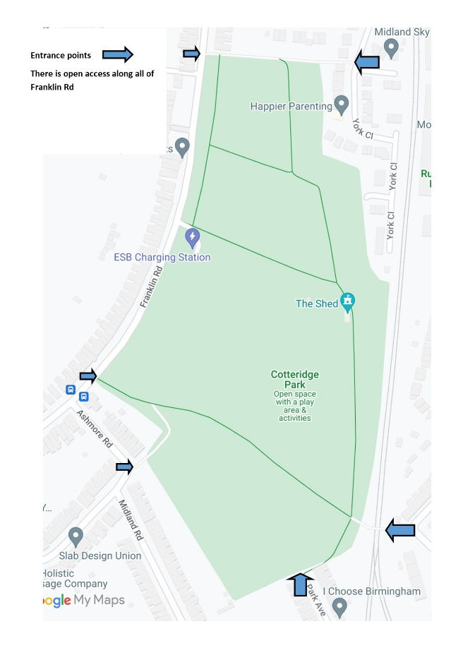
.
4) Who owns the asset in question?

a) Is the Council the owner of the asset? If yes, please proceed to Q6.
Yes (this is the case for most BOSF members – but you can check with BOSF if you’re not sure)

This may be confirmed by contacting the Council’s Property Records team based at: 10 Woodcock Street, Birmingham B7 4BL, telephone number 0121 303 3940 or email askpropertyrecords@birmingham.gov.org
b) Is the asset privately owned? If yes, please supply proof in the form of copy Title documents and plan: this is information is required if the asset is listed and it would be helpful if these details could be supplied to assist the Council in contacting the owners in respect to the nomination for listing. Information may be obtained online from: www.landregistry.gov.uk/

HM Land Registry,
Leigh Court,
Torrington Avenue,
Coventry, CV4 9XZ,
Tel: 0844 892 1111

Owner 1 – name and address
…………………………………………………………………………………………
Include info here about any organisations that own or lease part of the site or write “not applicable”
…………………………………………………………………………………………

Leaseholder Yes/no
Freeholder Yes/no

Owner 2 – name and address

…………………………………………………………………………………………

…………………………………………………………………………………………

Leaseholder Yes/no
Freeholder Yes/no

If there are more than two freehold or leasehold owners please give their details on a separate sheet to accompany this application.

5) Who are the current occupiers of the asset?

Please supply proof: this information is required if the asset is listed and it would be helpful to assist the Council in contacting the occupiers in respect to the application for listing. Information may be available from HM Land Registry at their address above.

Occupier 1 – name and address

……… Include info here about any organisations that make occupy part(s) of the site

…………………………………………………………………………………………

Occupier 2 – name and address

…………………………………………………………………………………………

…………………………………………………………………………………………

Occupier 3 – name and address

…………………………………………………………………………………………

…………………………………………………………………………………………

Please add the details of any other occupier of the asset on a separate sheet to accompany this application.

This is to assist the Council in deciding whether or not the asset meets the criteria for listing. (See attached guidance on ‘Definition of an asset of community value’)
6) What reasons do you have for nominating the asset, why do you think it is of community value?

As the community group that has been looking after XXX Park since XXXX we believe we are able to demonstrate that the park is an essential asset for our community.

XXXX Park offers the obvious benefits of a park;
- A place for children to play
- For dogs to be walked
- For exercise to be taken
- Open access to basketball and tennis courts and a skatepark
- For friends, family and colleagues to meet (especially important during the pandemic)
- A place to enjoy nature on your doorstep.
(add or take away from this list to show what the park offers your community)

In addition, the park provides essential environmental benefits for the community;
- The plants, trees and grass improve air quality
- The grassed and wooded areas provide a place storm water run-off – protecting streets and homes from flooding
- The trees help mitigate the urban heat island effects of rising global temperatures

The park also provides opportunities for members of the community to improve their mental and physical health and mitigate the damage done by loneliness and isolation.

XXX Park offers: (add or take away from this list to show what the park offers your community)

- Volunteering opportunities for all ages
- Physical activities – including running for beginners, walking groups, walking netball, dance, tai chi, forest school
- Social interaction – over 50s groups, knit and natter, art group, parent and baby sessions, chess club, woodcarving for beginners and a youth club
- Access to toilets and hot drinks
- Space for other groups in the community to meet

The park is also used, independently and working with FoXX Park, by several local organisations – stakeholders in the future of the park:
(give local examples or who else uses the open space)
- Local schools –
- Uniformed youth groups – Sea Cadets, Scouts, Brownies etc
- Non-uniformed youth groups –
- Faith groups –
- Sports and exercise groups –

Future Use
The park has been in existence for over XXX years and the community group supporting it has been constituted for XX years.

The local community have demonstrated their willingness to contribute time and money to the park’s current and future sustainability.

The volunteers work hard to raise funding, working with a variety of funders, to ensure the future community value of the park.

Currently the park is managed as a co-production between Birmingham City Council, who is the landowner, and Friends of XXX Park.

Include here if you have a management plan for the site/building that identifies future activity

We believe that this is the best model for the sustainable future of the park - as there are huge benefits in economies of scale of being one of the 570+ parks in the city that BCC looks after.

However, if for any reason, that model is no longer appropriate the local community will work to find ways to ensure that the park continues to serve the needs of the community.

XX Park is a current successful asset hosting many activities for community benefit and will remain an essential asset in the future.

XXX Park is an asset - it is well loved, important to the community, much needed and could not be replaced if lost to the community

7) Declaration

This must be signed by the appropriate authorised officer in your organisation.

The Council would like to receive as much information as possible. Please confirm that:
- the information contained within this application is correct and complete
- the required supporting documents referred to in this application are attached:
- Site Plan
- Proof of ownership and occupation – in Birmingham City Council’s ownership
- Copy of Articles of Association/Trust Deed/Constitution As appropriate

Full Name: …………… ………………………..

Signature: ……………………………………

Date:

Position in organisation: …Trustee………………………………………………………

E-mail: ……………………………………………………………………………
Telephone: ………………………………………………………………

Nomination by post: Applications and supporting documents must be clearly marked as ‘Asset of Community Value Nomination Form, Confidential’ to the address given above.

Applications by electronic mail will be accepted. All supporting documents must be included as e-mail attachments with the nomination, otherwise it will not be considered. Nominations should be e-mailed to the address above.

NB please retain a copy of this form for your records and should your circumstances or contact details change then please let the appropriate contact officer know.

This information will be held in accordance with the Data Protection Act 1998 and information contained herein shared with officers and elected Members from Birmingham City Council and retained for 5 years.

Guidance

Definition of an Asset of Community Value

Section 88 (1) of the Localism Act 2011 defines an asset of community value as:

A building or other land in a local authority’s area is land of community value if in the opinion of the authority—
(a) an actual current use of the building or other land that is not an ancillary use furthers the social wellbeing or social interests of the local community, and;
(b ) it is realistic to think that there can continue to be non-ancillary use of the building or other land which will further (whether or not in the same way) the social wellbeing or social interests of the local community.
Social interests includes (in particular) cultural, recreational or sporting interests
Section 88(2) of the Act extends this definition to land which has furthered social wellbeing or interests in the recent past, and which it is realistic to consider will do so again during the next five years.. There is no definition as to what constitutes the recent past and this is left to the Council to determine.
Exclusions
There are some categories of assets that are excluded from listing. The principal one is residential property. This includes gardens, outbuildings and other associated land, including land that it is reasonable to consider as part of the land with the residence where it is separated from it only by a road, railway line, river or canal where they are in the same ownership as the associated residence. Details of this are set out in paragraphs 1 and 2 of Schedule 1 to the Assets of Community Value Regulations 2012
There is an exception to this general exclusion of residential property from listing; where an asset which could otherwise be listed contains integral residential quarters, such as an accommodation as part of a pub or a care taker’s flat, the asset will not on that ground be excluded from listing.
There are two further categories of assets excluded from listing:
a) Land licensed for use as a residential caravan site (and some types of residential caravan site which do not need a licence), in paragraph 3 of Schedule 1
b) Operational land of statutory undertakers as defined in s 263 of the Town and Country Planning Act 1990, in paragraph 4 of Schedule 1 (e.g. land owned by utility companies, the civil aviation authority, the post office etc), which is organisations like the Post Office, Civil Aviation Authority, Transport providers, utilities, etc.

